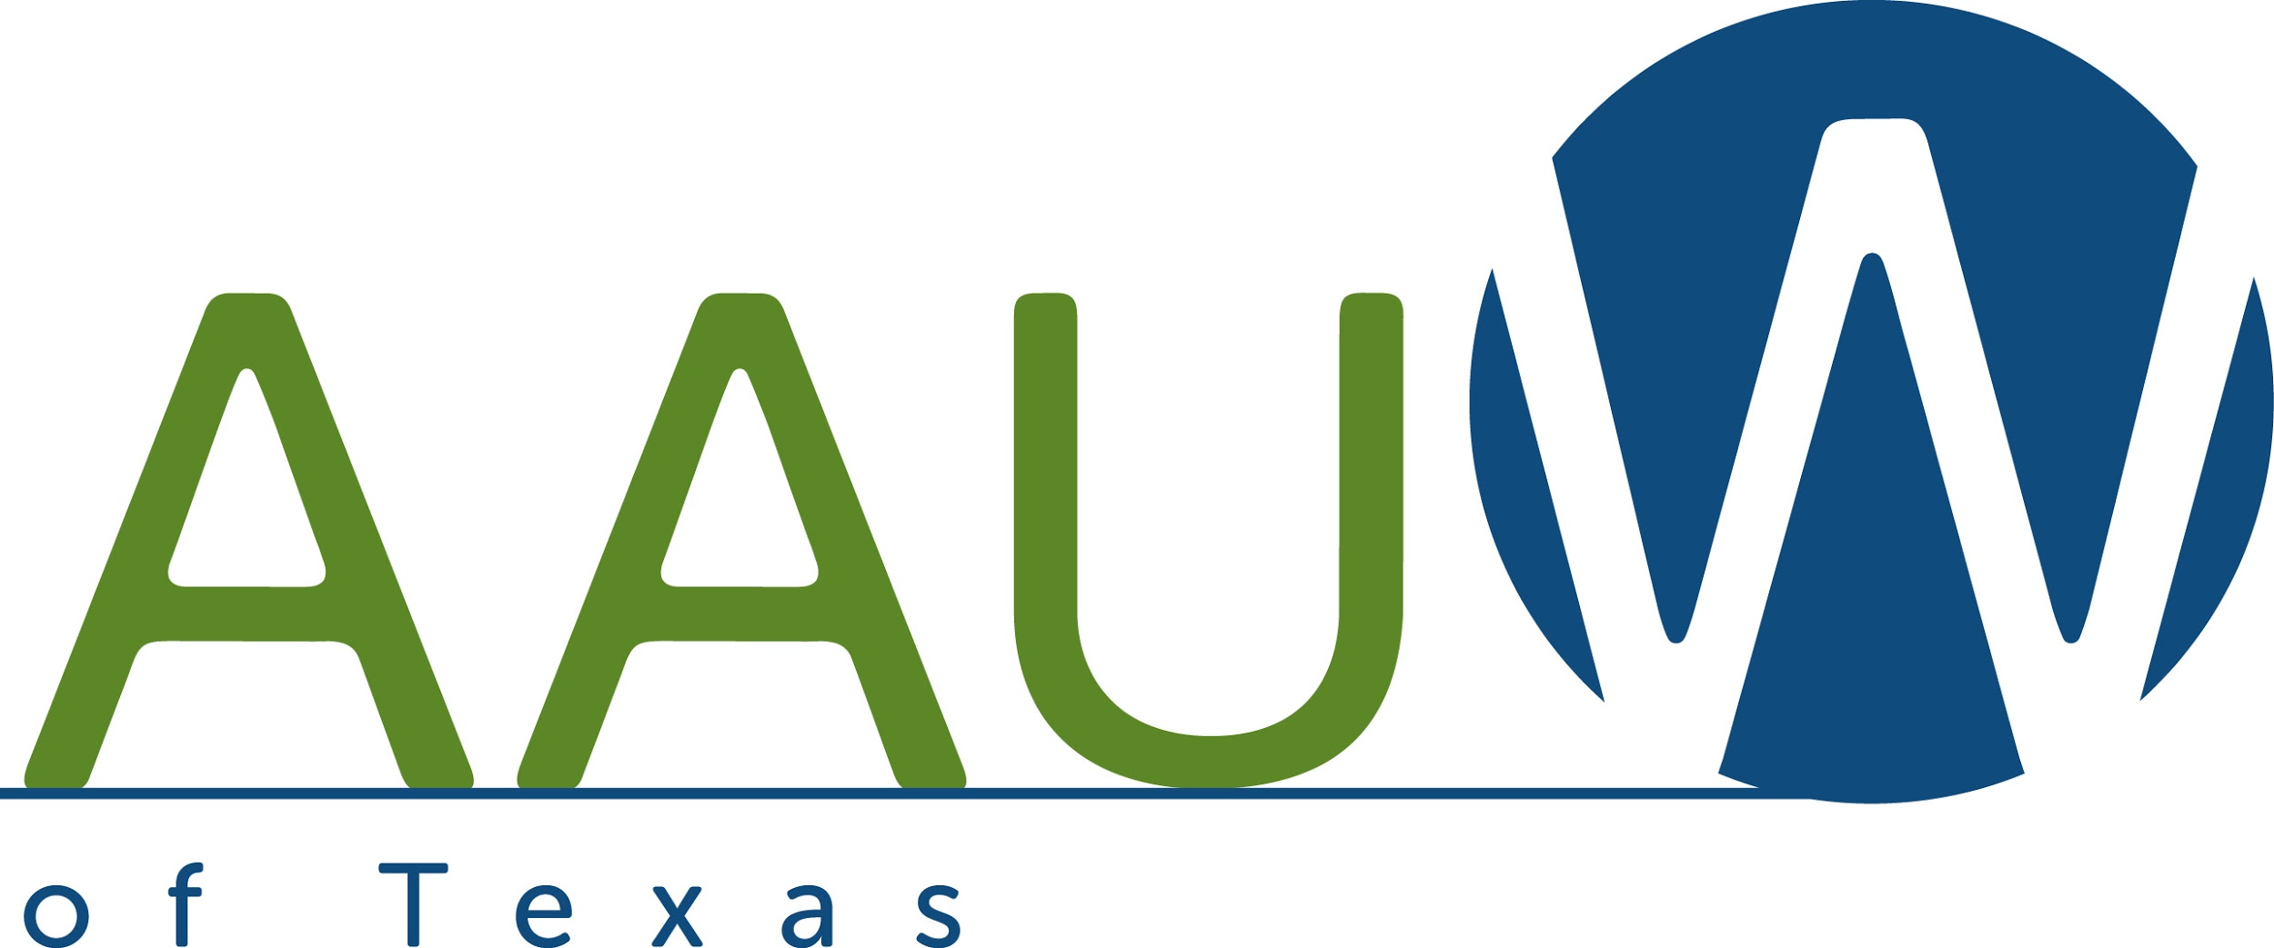
REAP the Benefits of Your AAUW Membership

We R.E.A.P. the benefits of our AAUW membership through Research, Education, Advocacy and Philanthropy. AAUW Texas seeks to recognize all the ways our Texas branches sow the seeds that reap benefits for our members and all women and girls in our communities.
This recognition program is just that…recognition of the work your branch does to level the playing field for women and girls through research, education, advocacy and philanthropy. This is not a competition…it is a way of acknowledging what you do and sharing your ideas with branches in other communities.
All branches who submit a R..E.A.P. application will be recognized at the AAUW State Convention in Austin in April. At that time, you may display scrapbooks, posters, flyers, etc. that illustrate your projects.
List and describe briefly in each section the actions that demonstrate your branch commitment to Research, Education, Advocacy, and Philanthropy. You do not have to complete all sections.
Deadline: March 15, 2016
Mail to: Margie Poole, State Branch Services Chair
9719 Cypresswood Drive, Apt. 1008
Houston, TX 77070-3117

Or send electronically to: margiepoole11@yahoo.com

Branch:

President: E-mail:

Financial Officer: E-mail:

Branch Website:

R – AAUW research is the foundation of all AAUW programs and projects. How does your branch support and/or use AAUW Research and/or research on women’s education and equity issues generated within your community?
Some ideas: Your book group has read Why So Few? or other AAUW research reports. Your branch has used the Program in a Box for a branch, school board, parent organization, faculty or other community meeting. Your branch has given a copy to your local public and college libraries. Your branch uses the Why So Few? research in planning or updating a STEM event. Your branch supports the Eleanor Roosevelt Fund which pays for our research.

E– Equitable and accessible education for all women and girls has been the bedrock of AAUW for 130 years.
How does your branch educate women and girls, including your own members?
- Some ideas: Your branch has co-sponsored a Campus Action Project or Legal Advocacy Fund event on a local campus. Your branch has co-sponsored a $tart $mart or Elect Her event for high school or college students. Your branch has sent a local student to NCCWSL or paid for a scholarship. Your branch sends leaders to district, state and national AAUW meetings. Each officer in your branch helps mentor new leaders

A – AAUW advocacy for laws that give women a fair chance has changed our world.
How does your branch advocate for AAUW issues?
Some ideas: Your branch members have helped educate and/or register voters. Your branch members subscribe to Mission in Action and Action Alert. Your branch and branch members support the Public Policy Fund. Your branch is planning an Equal Pay Day event. Your branch members write letters and send e mails to your elected representatives in local, state, and national offices. Your branch has used a PIAB to educate your community about Title IX, the Safe Campus Act, the National Women’s Museum, and/or Pay Equity.

P – AAUW philanthropy is the engine that drives our programming.
How does your branch’s philanthropy support AAUW’s programs both nationally and locally?
Some ideas: Your branch and branch members support at least one of the AAUW Funds. At least one of your branch members is a member of the Legacy Circle. Your branch funds a local scholarship for a graduating senior, a proven scholar, or a member. Your branch sends a young woman to NCCWSL.

