How to make a public electronic comment on a bill
To find committee meetings and be able to comment on a specific bill being discussed go to Texas Legislature Online (TLO) at https://capitol.texas.gov/ The TLO website provides information on legislation, committees, house, and senate. Choose Committees. The drop down will allow you to choose upcoming meeting and either House or Senate.

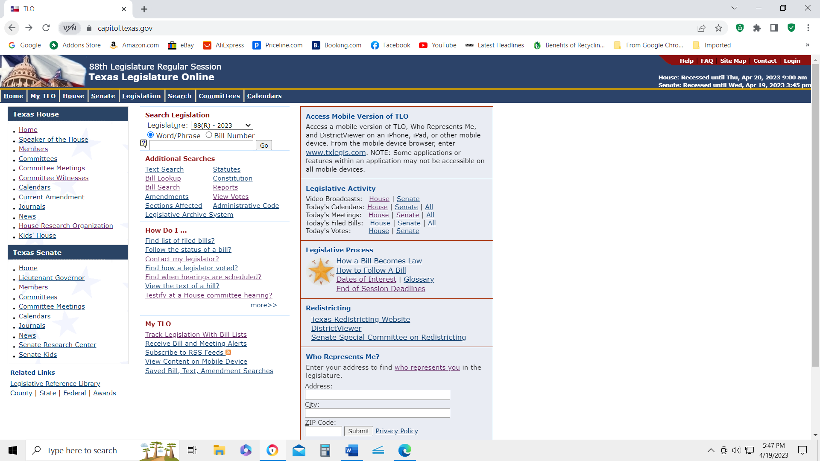
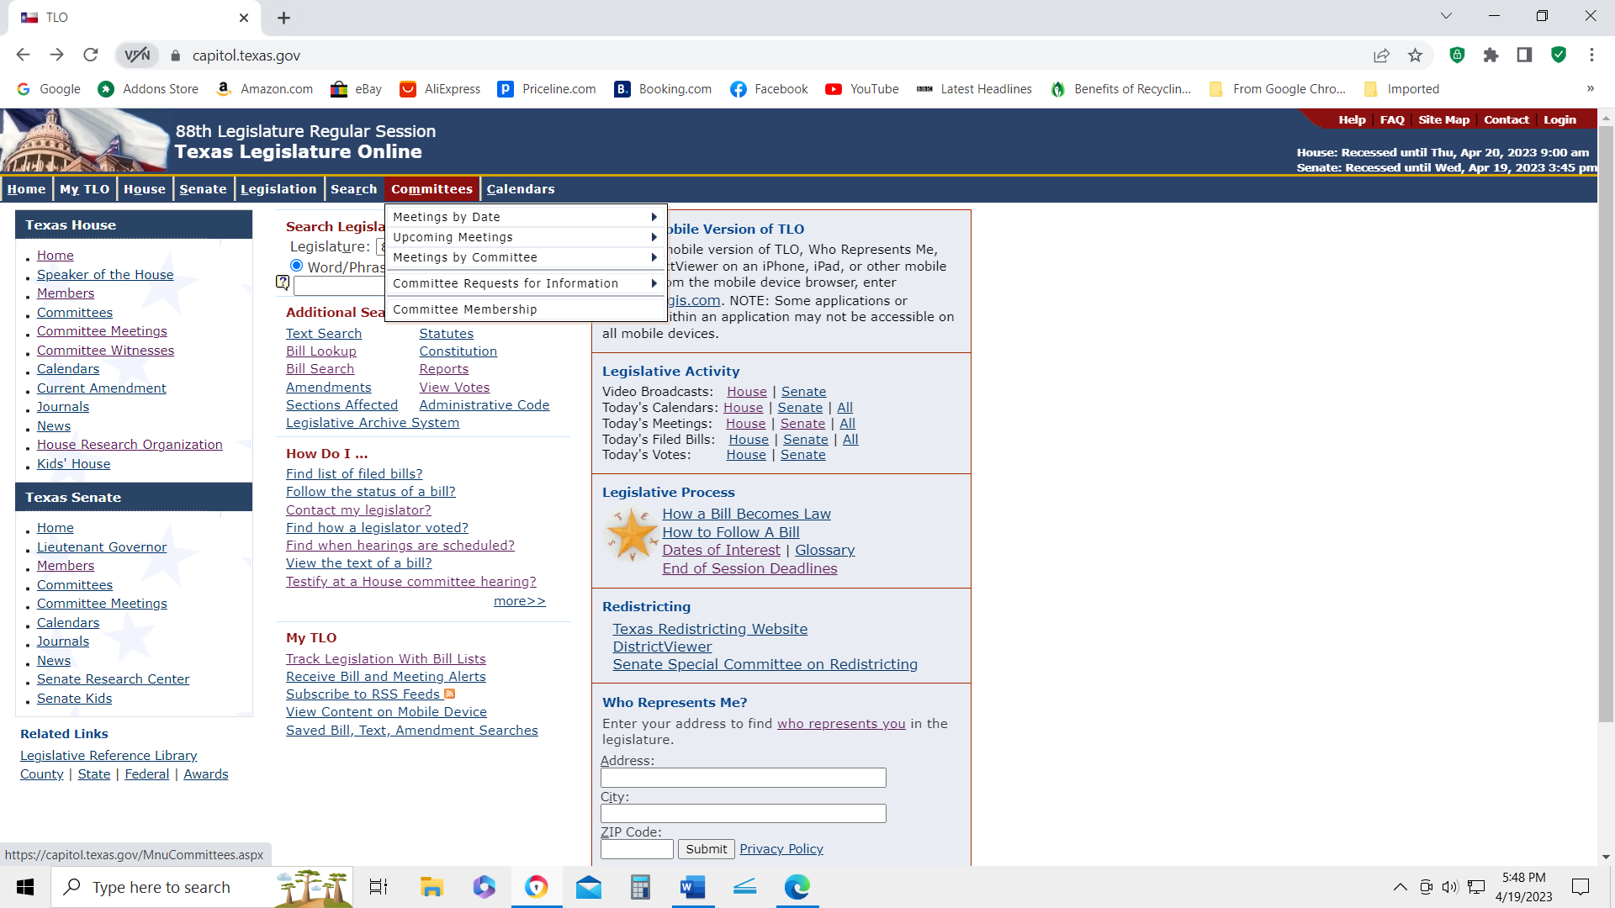
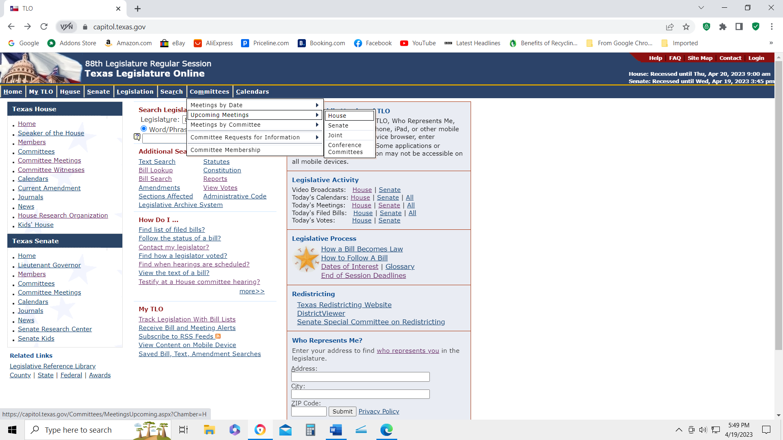

Choosing House, in this example, brings up by date bills that will be presented in scheduled committee meetings this week. Choose the Committee you are interested in and then from in the right-hand column choose the hearing notice.
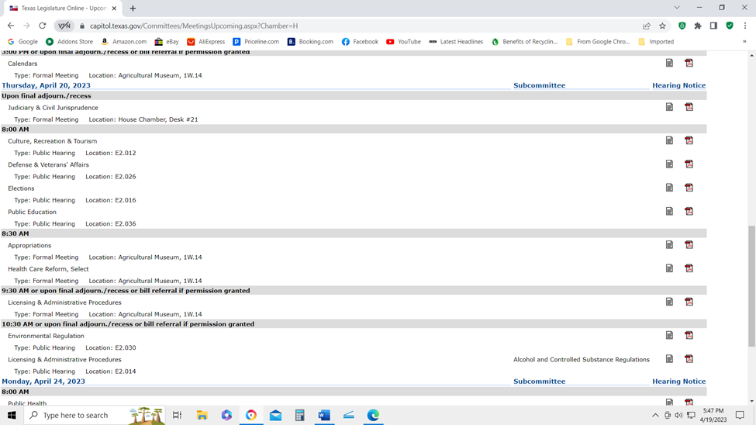

The hearing notices identifies all bills to be discussed. At the bottom of the hearing notice pages you will find a link to a live broadcast of the hearing, and link if you want to electronically submit comments related to specific bills.
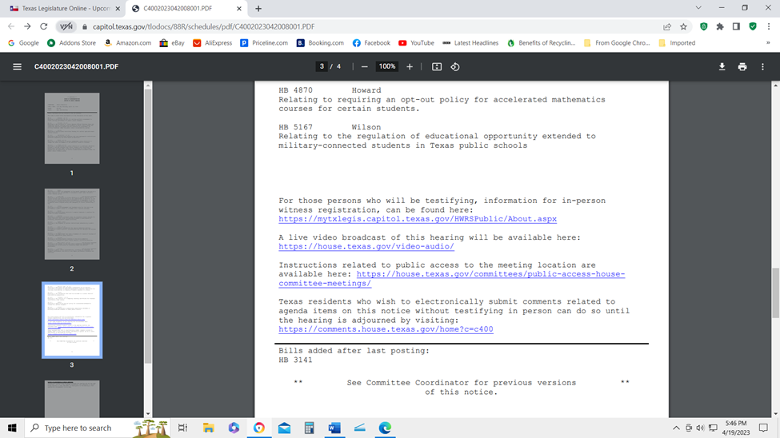

Complete the form.
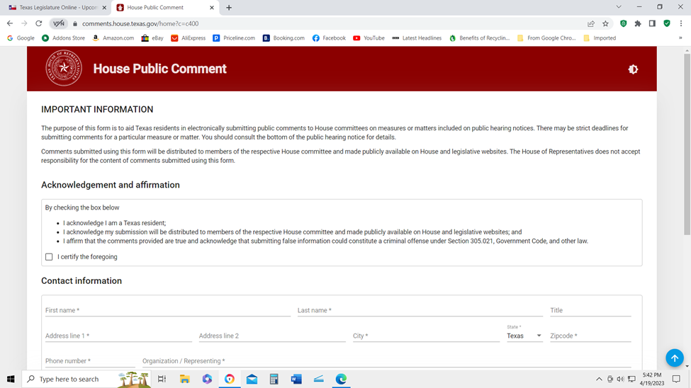
Then select and make comments on the bill of your choice. Submit.
